### PROJECT REPORT

**THE TRAGEDY OF FLIGHT:**

**A COMPREHENSIVE CRASH**

**ANALYSIS**

BY,

B.C.MEERA ABIRAMI

M.KEERTHIPRIYA

A.KAVIYA

K.KRISHNAVENI

**1.INTRODUCTION**

**1.1.OVERVIEW:**

**ABOUT PROJECT:**

## plane crash 3

* **Aviation accident analysis is performed to determine the cause of errors once an accident has happened. In the modern aviation industry, it is also used to analyze a database of past accidents in order to prevent an accident from happening.**
* **Per the convention on International Civil Aviation if an aircraft of a contracting state, the state where the accident occurs will institute an inquiry. The convention defines the rights and responsibilities of the states.**
* **ICAO Annex 13-Aircraft accident and incident investigation-defines which states may participate in investigation.**
* **In our project we done the visualizations to identify the maximum accidents, in which area maximum accidents happened, and which operator made more accidents compared to another and so on**

**1.2.PURPOSE OF THE PROJECT:**

* **The primary purpose of air crash investigators is to determine the cause of the crash and any contributing factors involved in the crash.**
* **Investigate authorities also provide recommendations for safe operations.**
* **Aviation accident analysis is an important part of aviation safety research.**
* **We used long-term sequence aviation accident statistics to analyze the characteristics of historical aviation accidents and predict the future direction of aviation accidents.Analysis is done for the purpose that prevent similar type accidents from recurring.**

1. **PROBLEM DEFFINITION AND DESIGN THINKING:**
   1. **EMPATHY MAP:**

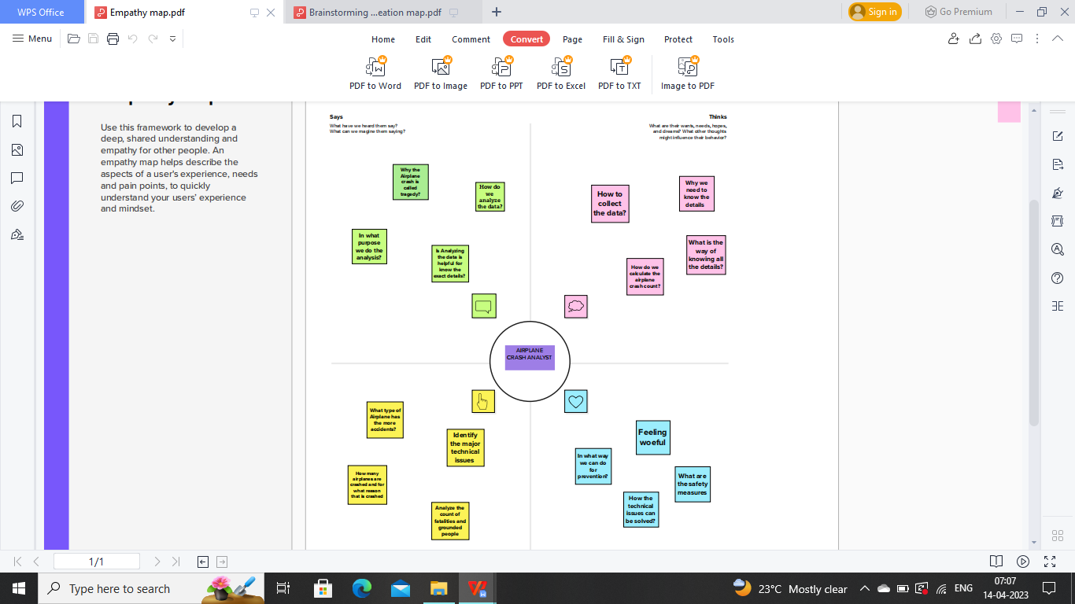

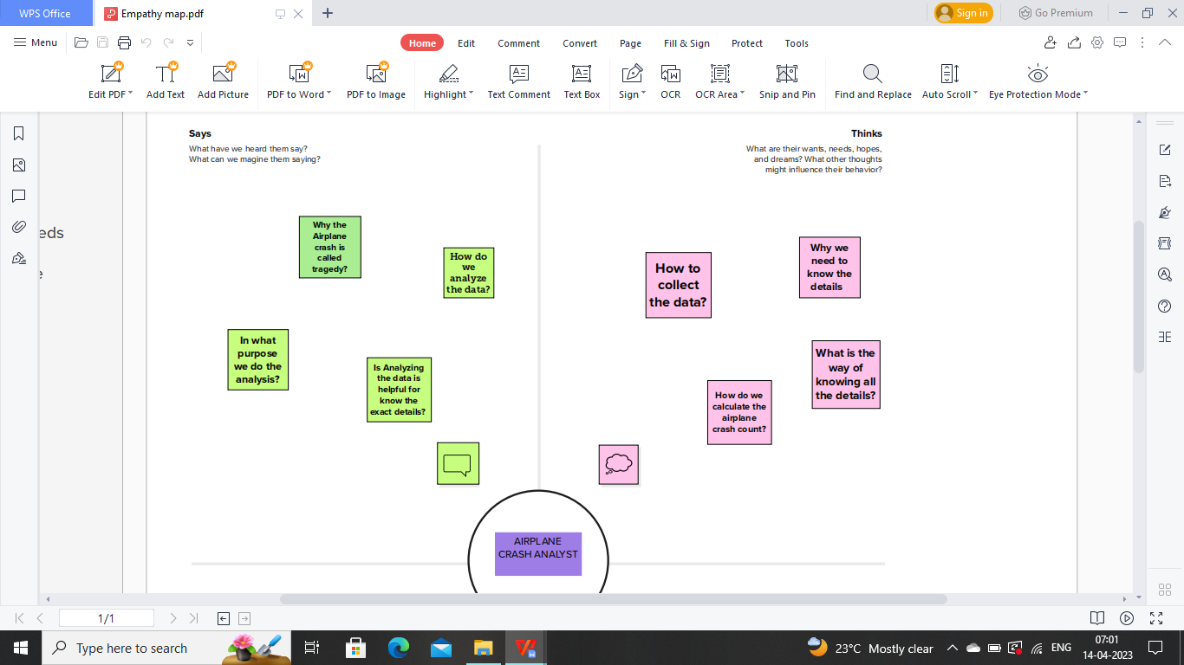

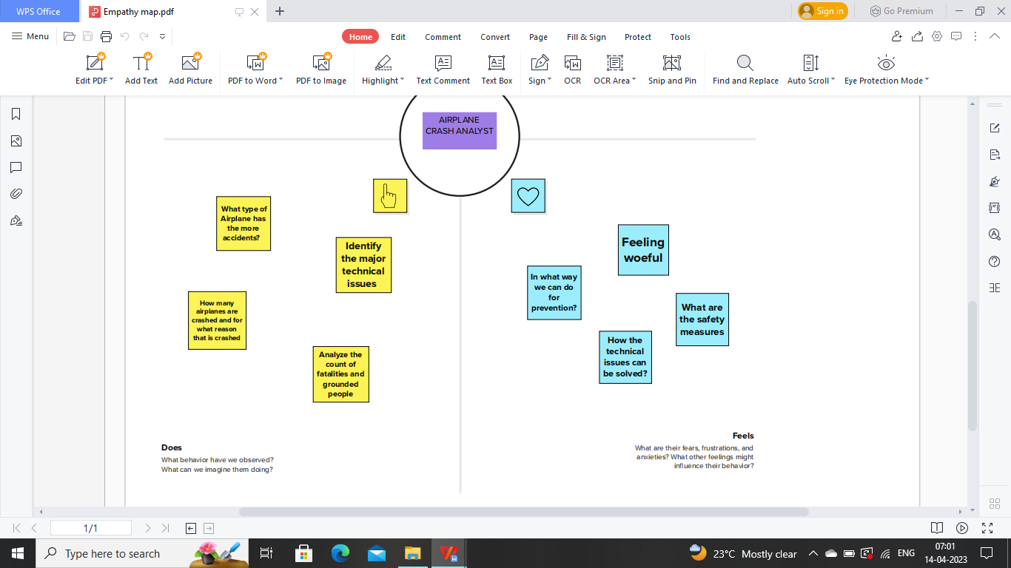

This picture represents the what we are thinking,saying,feeling about our project and what we have to do for our project.

* 1. **IDEATION AND BRAINSTORMING MAP:**

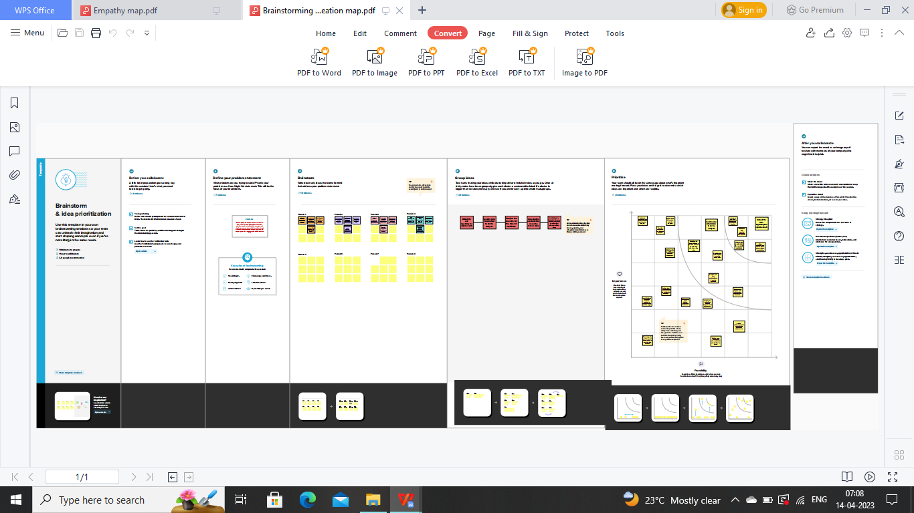

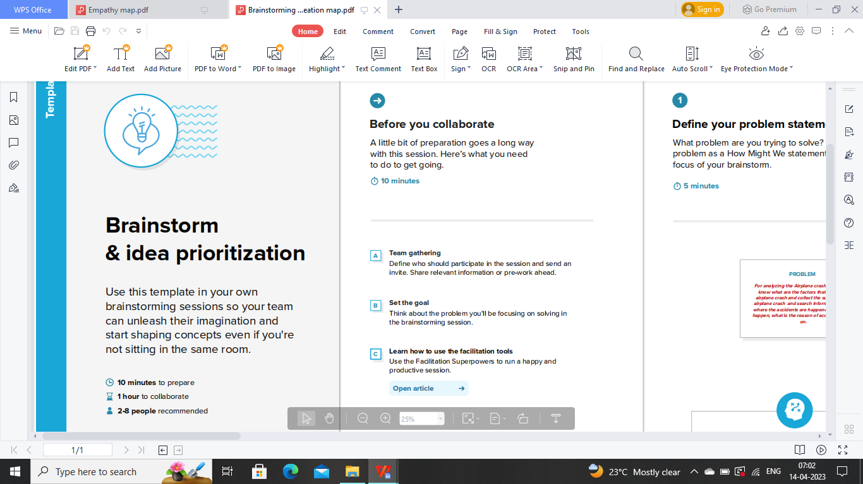 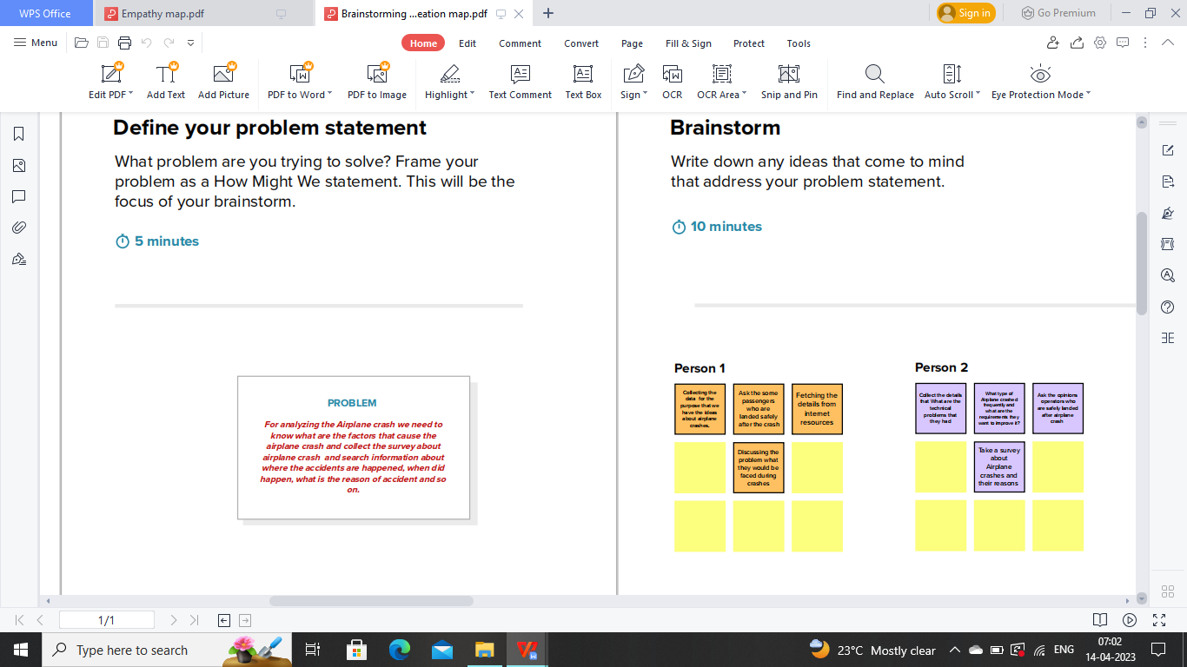

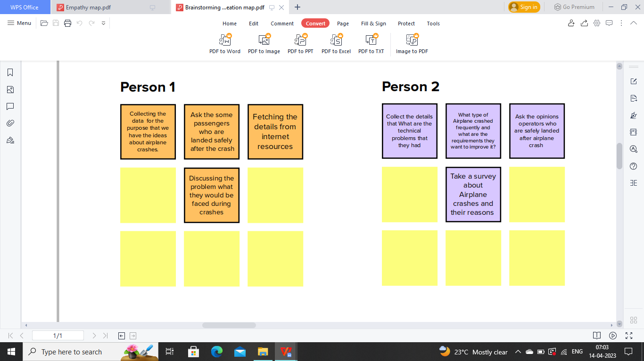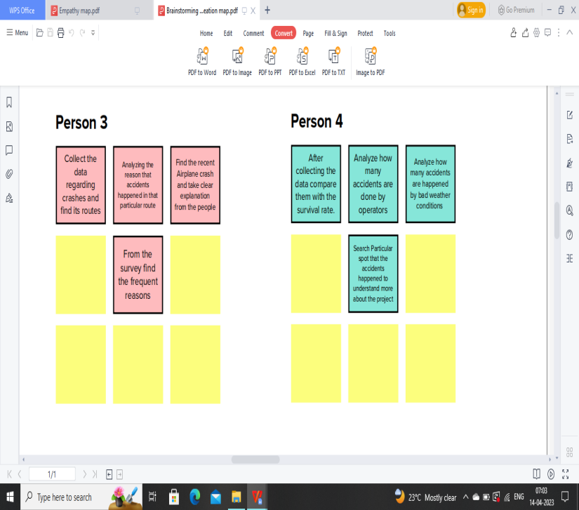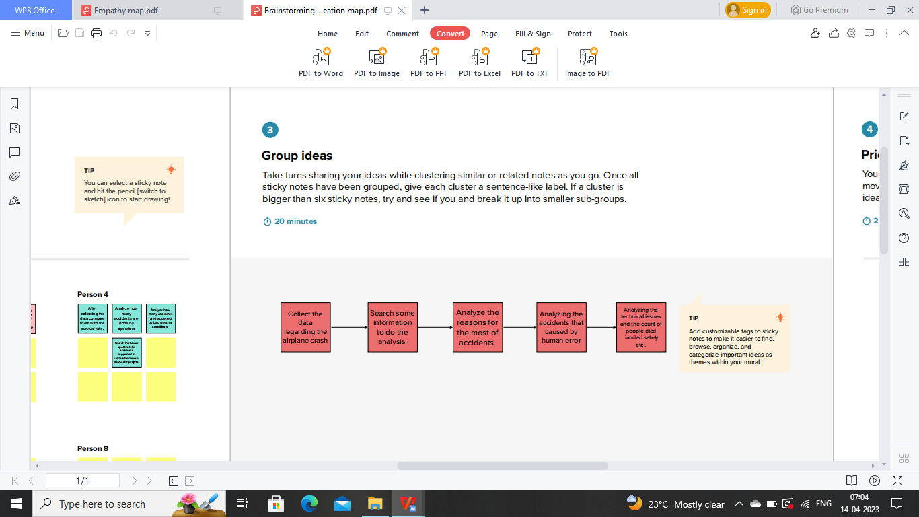

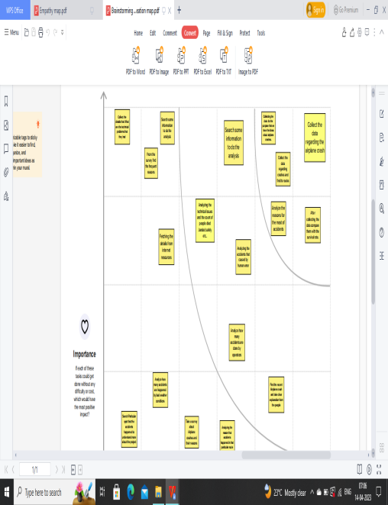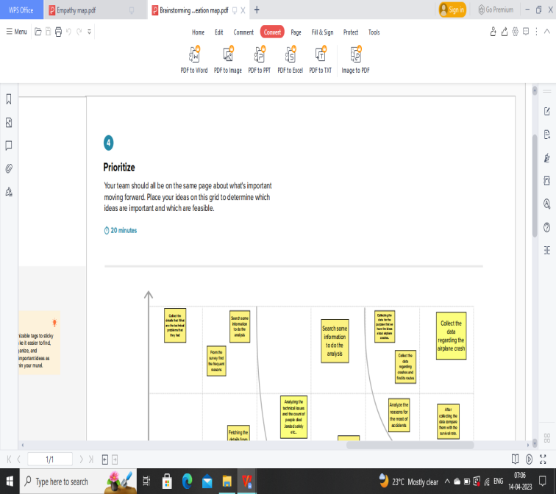

**The above map represents the details about what is the problem is, and what are the ideas of each team member and what are the group ideas and which should be prioritize first.**

**It shows our clear idea about our project.**

**3.RESULTS:**

**Here we share the final final findings of the project like dashboard, Story and the web page we create.**

1. **DASHBOARD:**

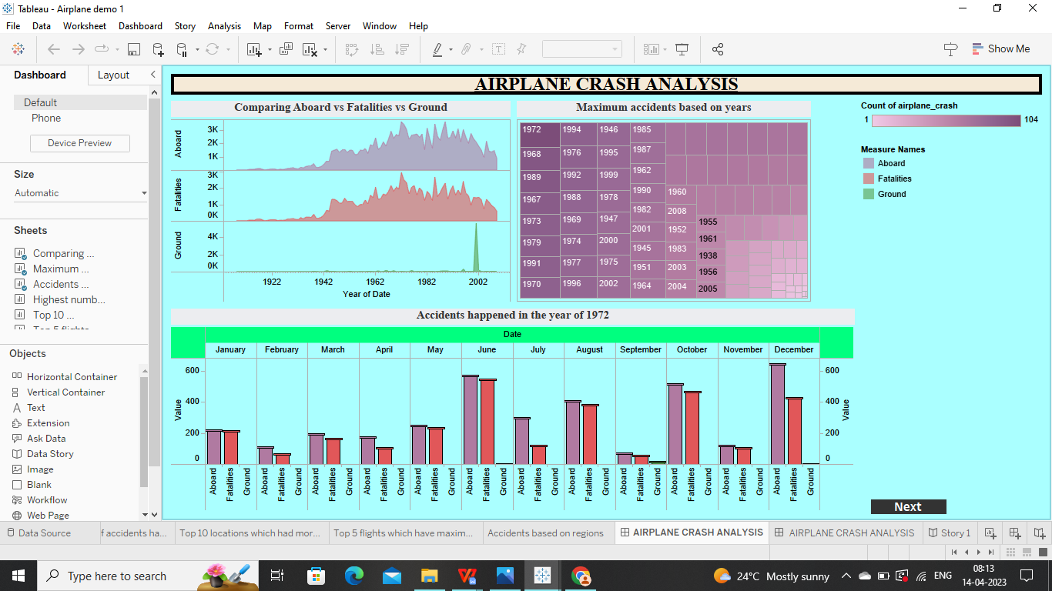

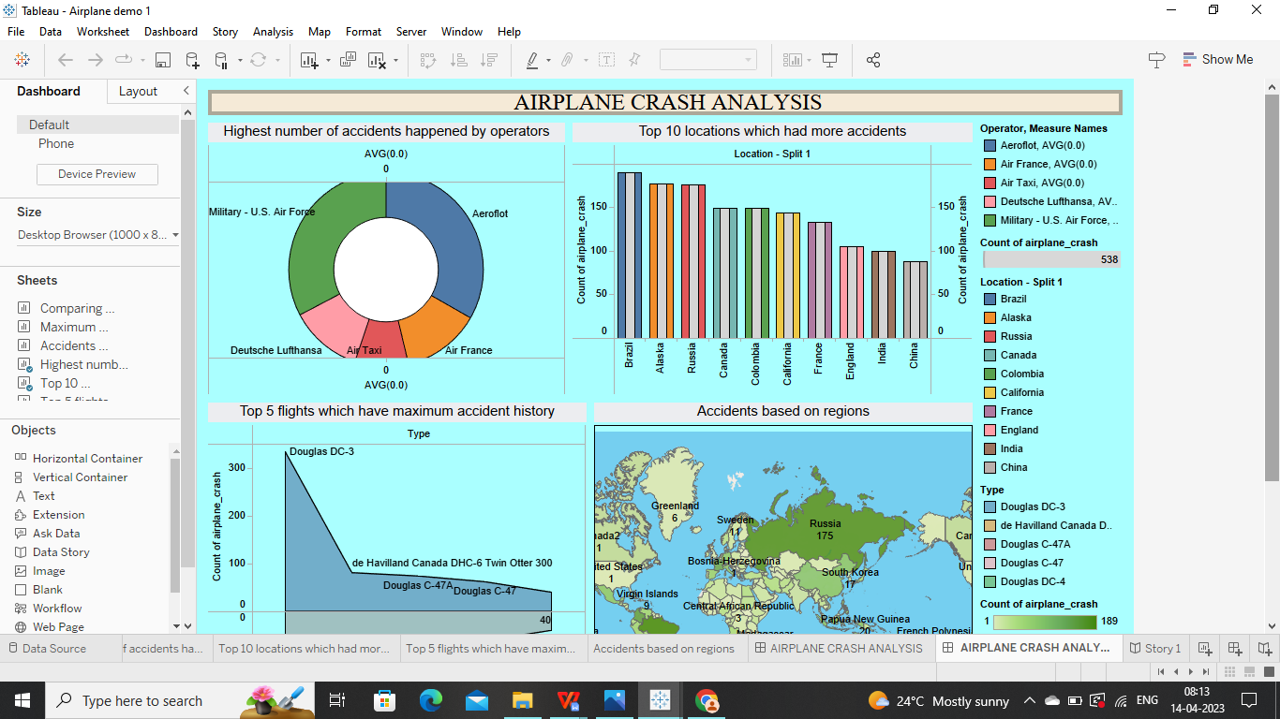

**2.STORY:**

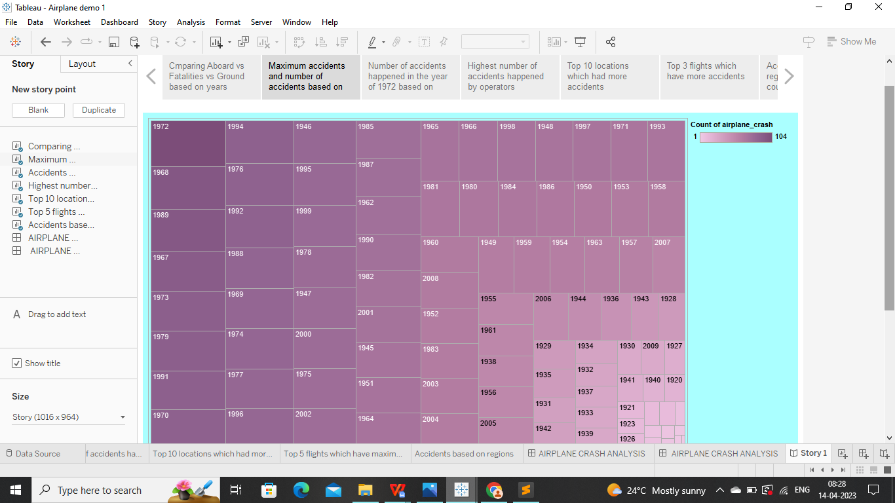

**3.WEB INTEGRATION OUTPUT:**

**In this field we show you the web integration we made through HTML file and this is the final output of our project.**

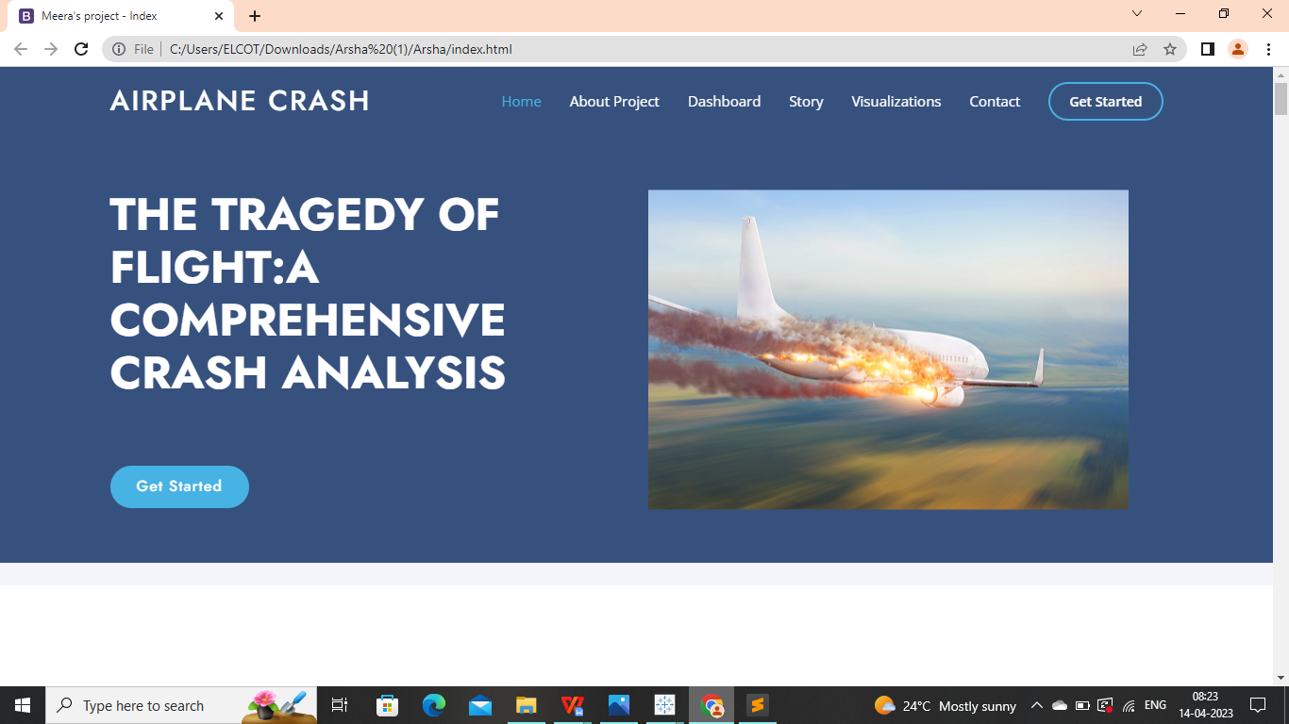

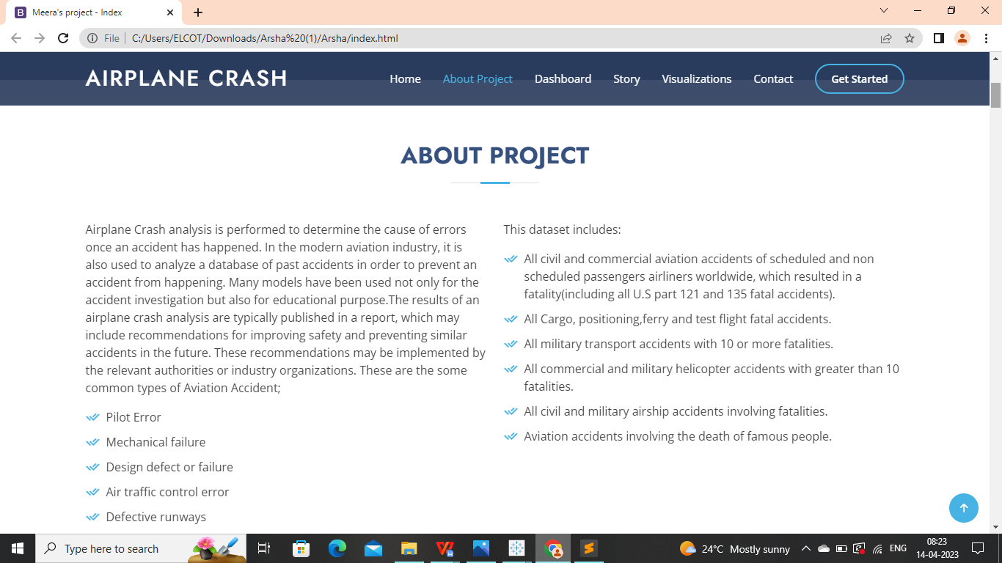

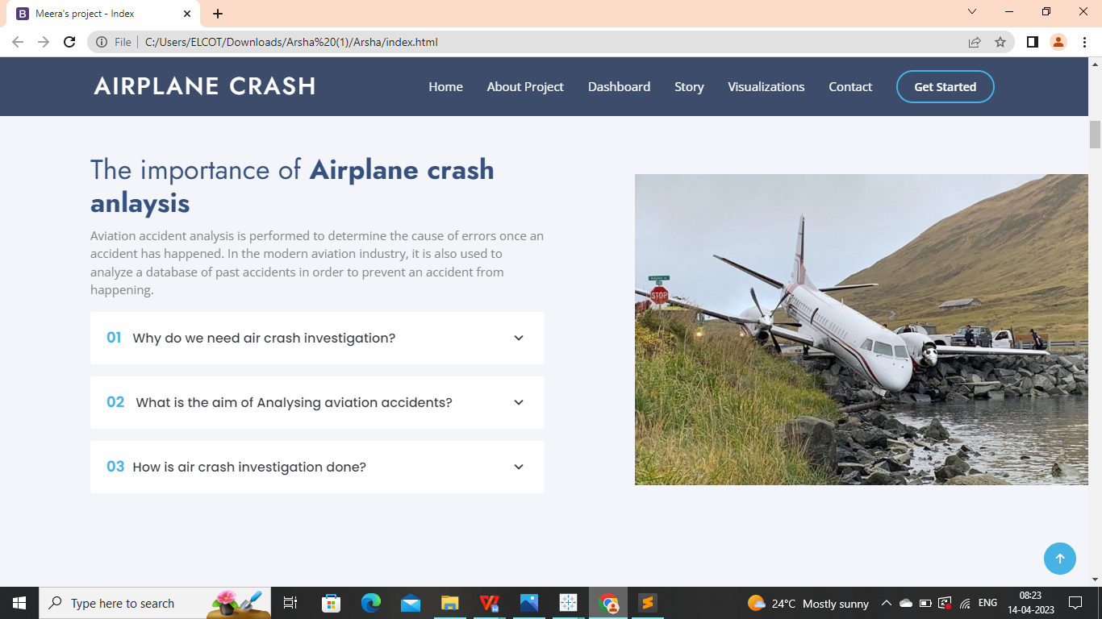

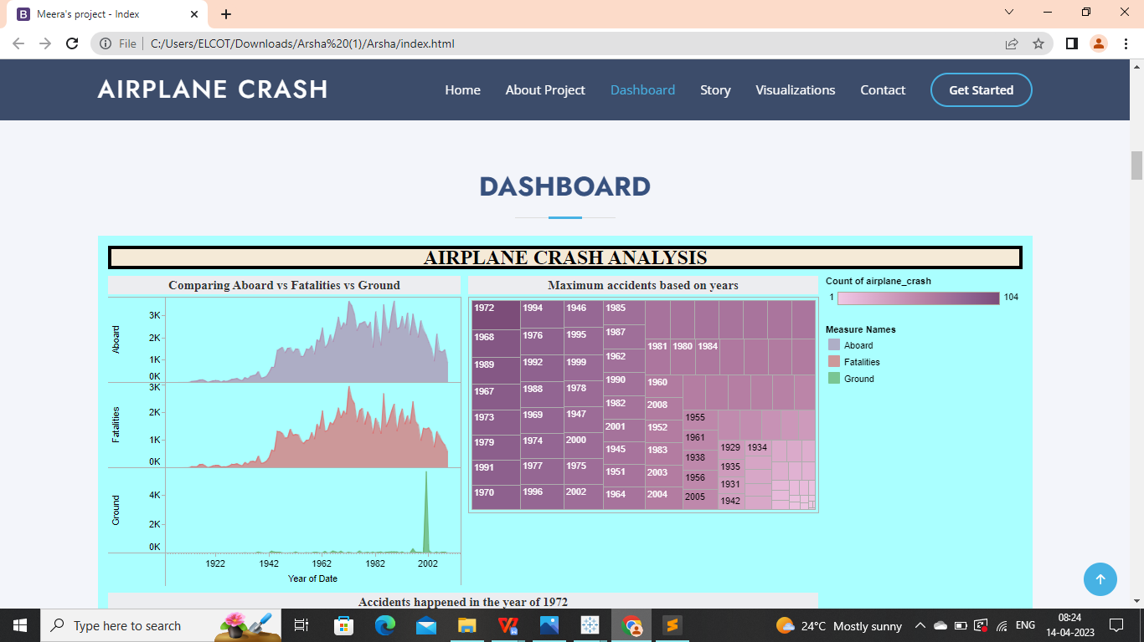

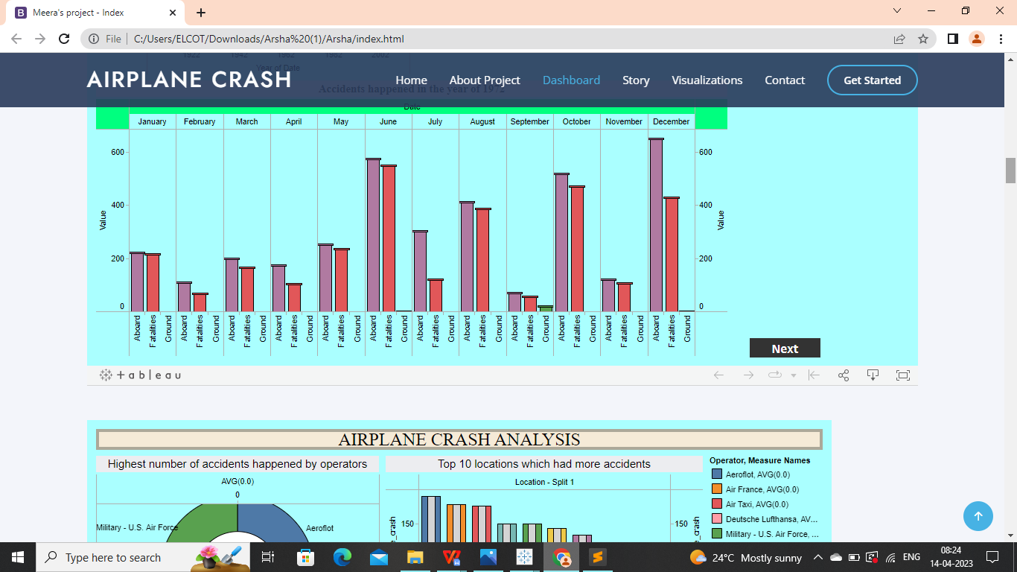

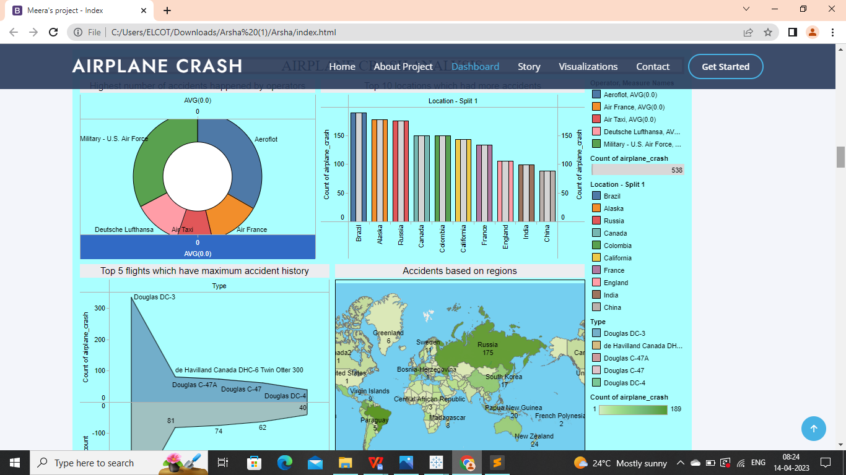

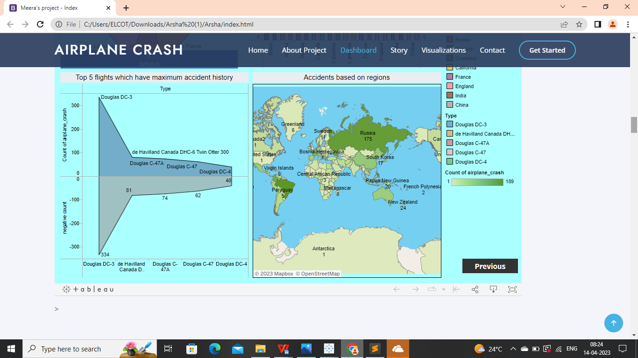

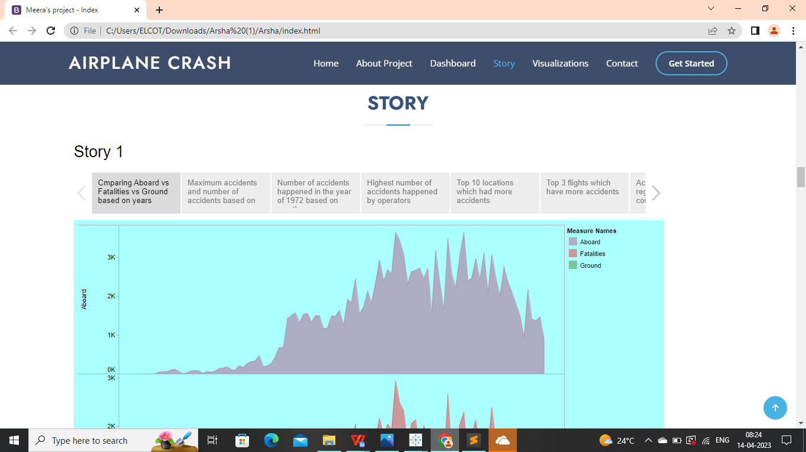

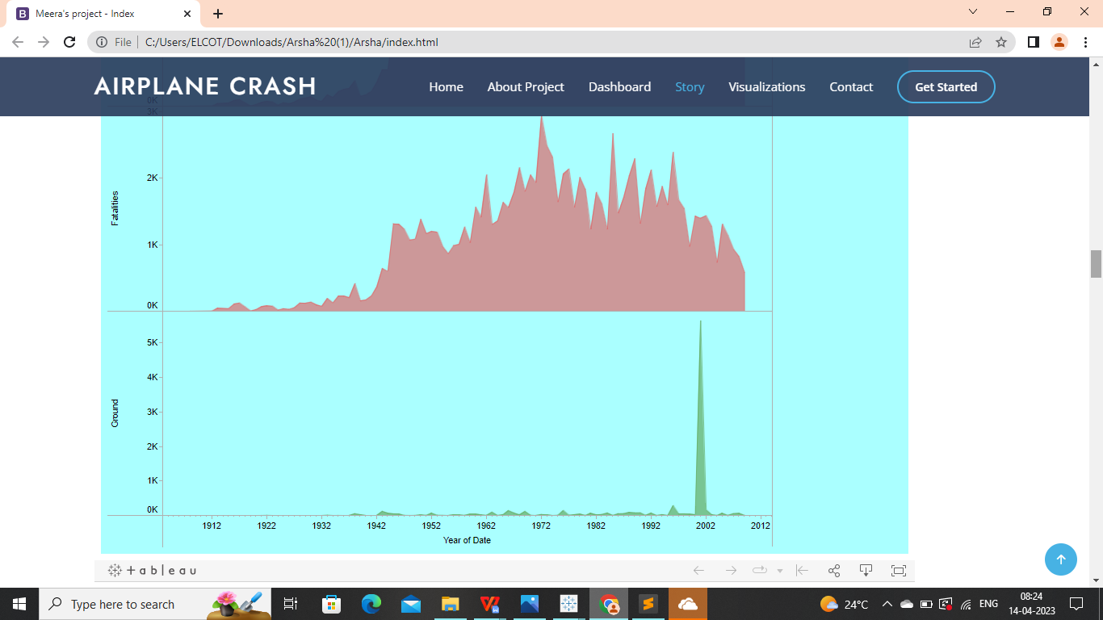

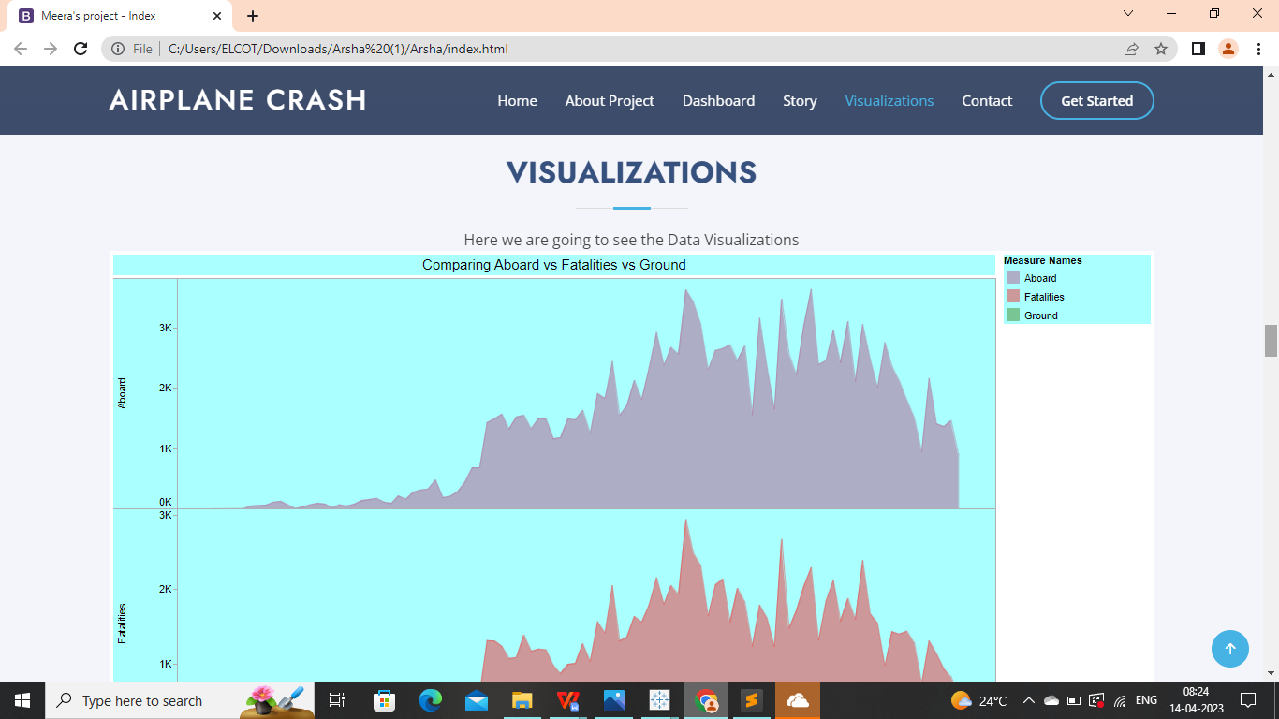

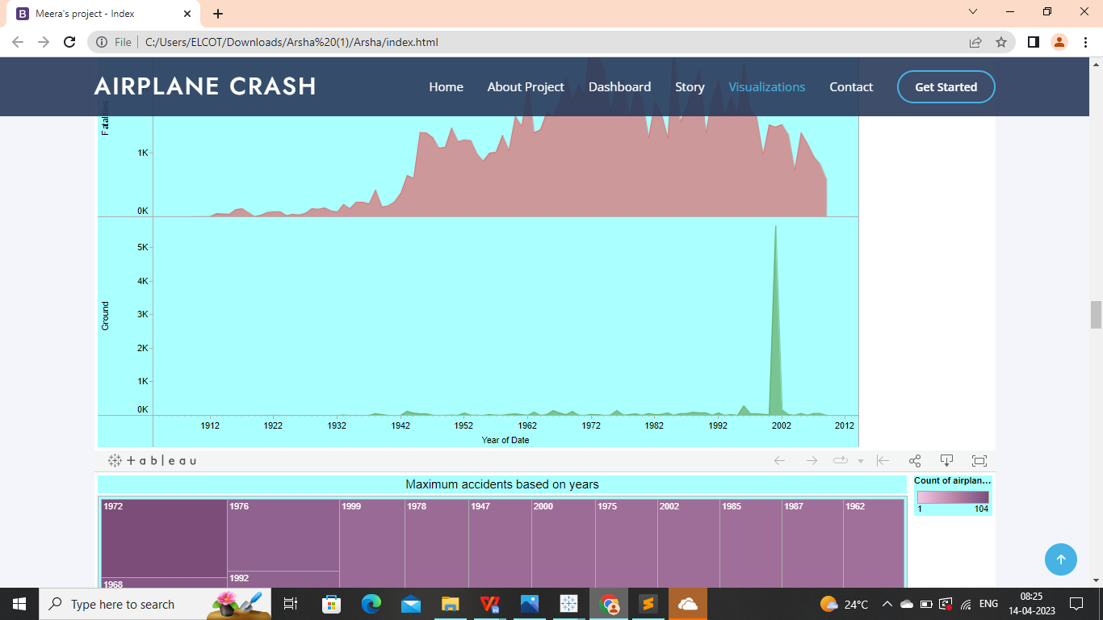



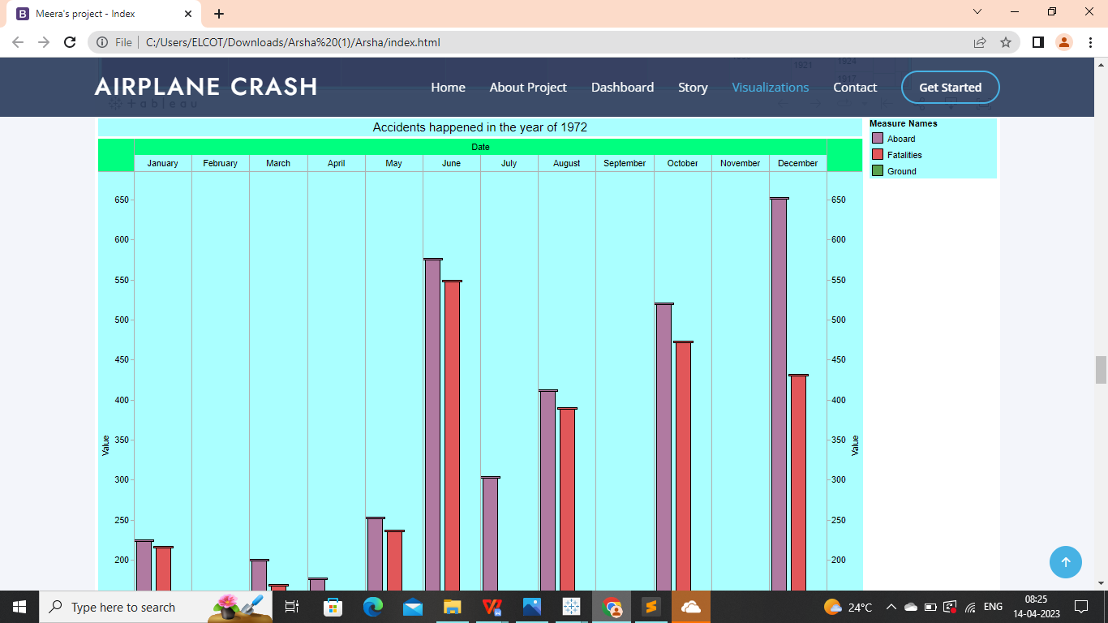

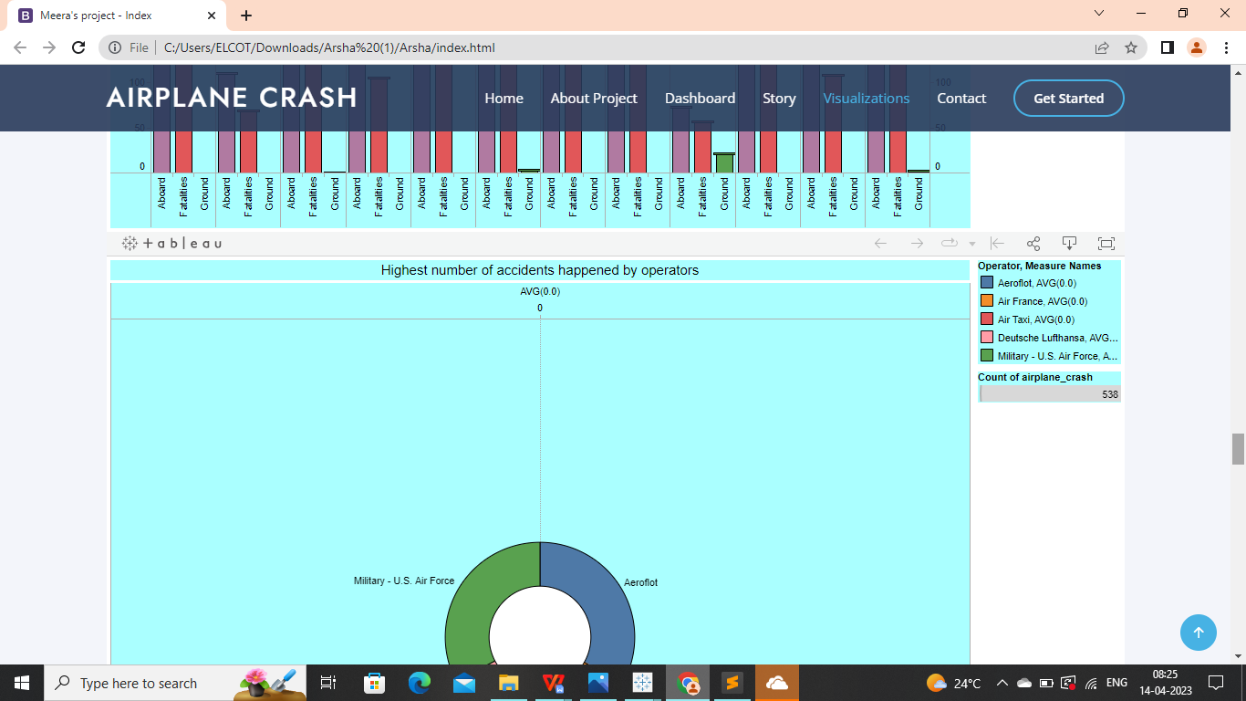

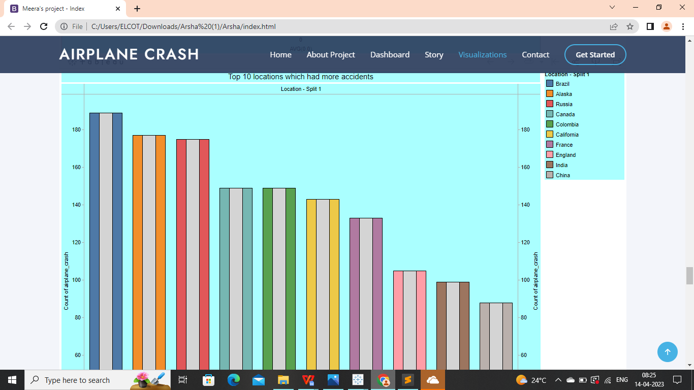

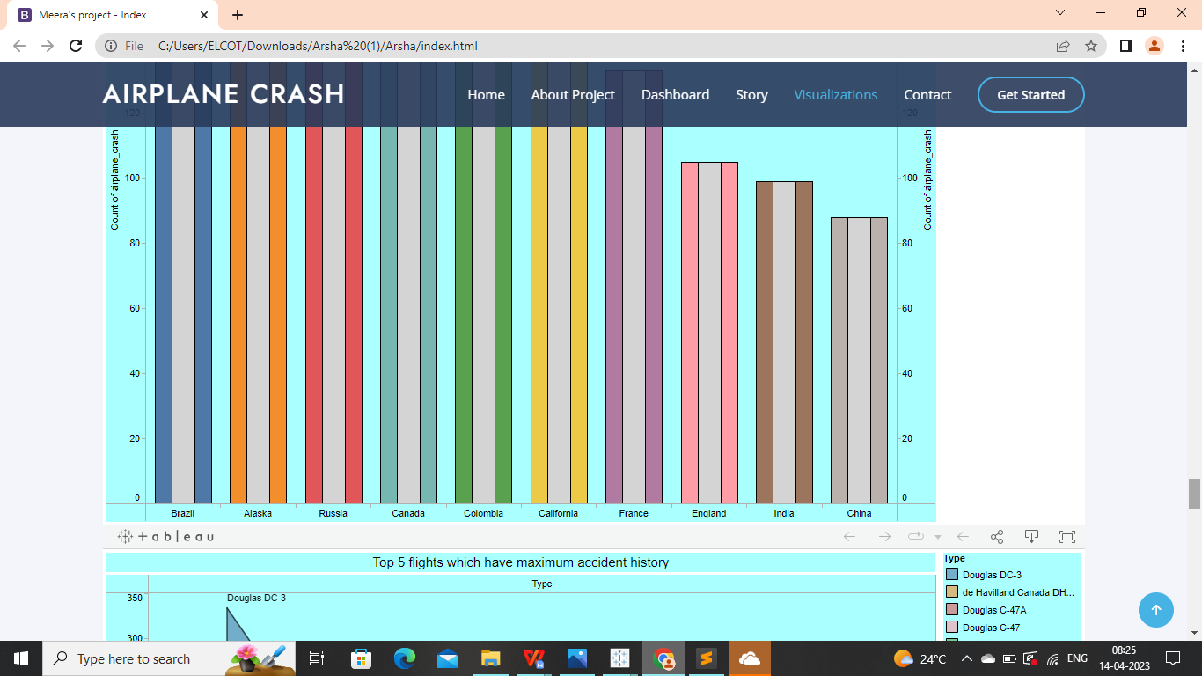

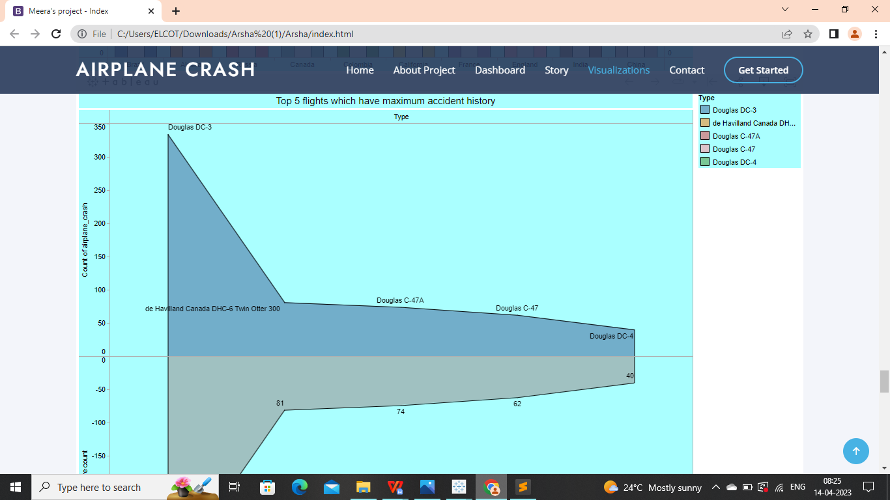

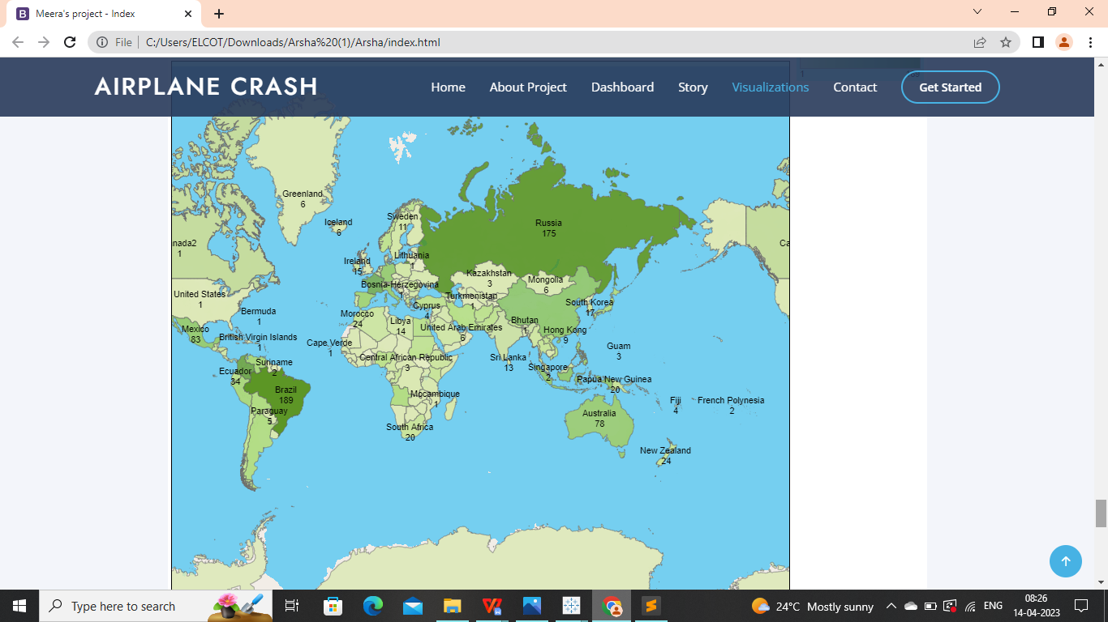

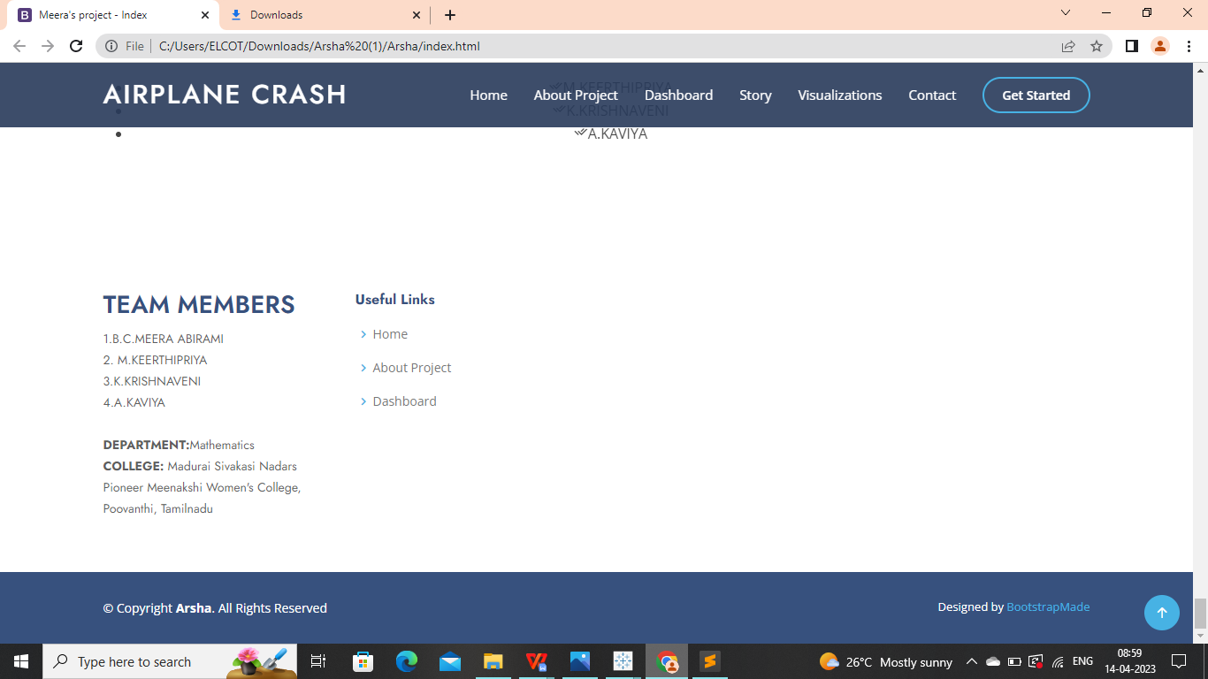

**PERFORMANCE TESTING:**

**1.AMOUNT OF DATA RENDERED TO DB:**

**DATA IMPORT USING Ms SQL:**

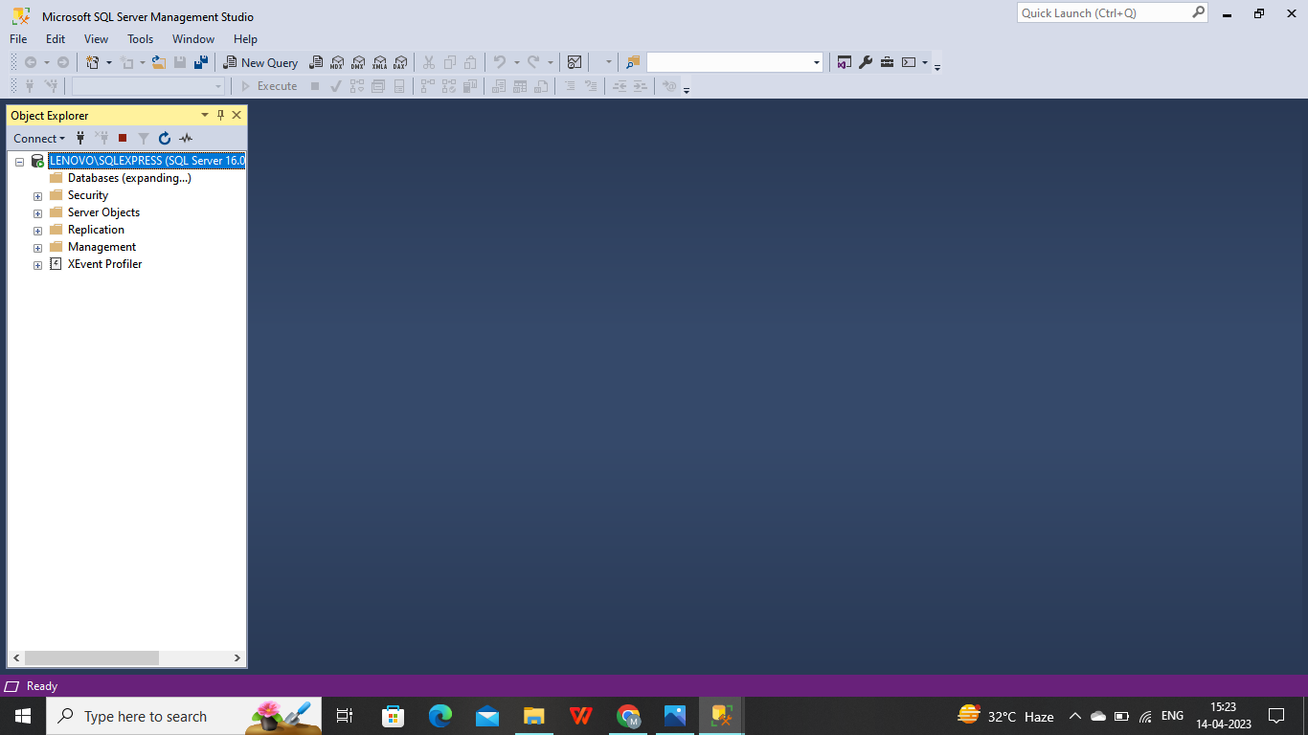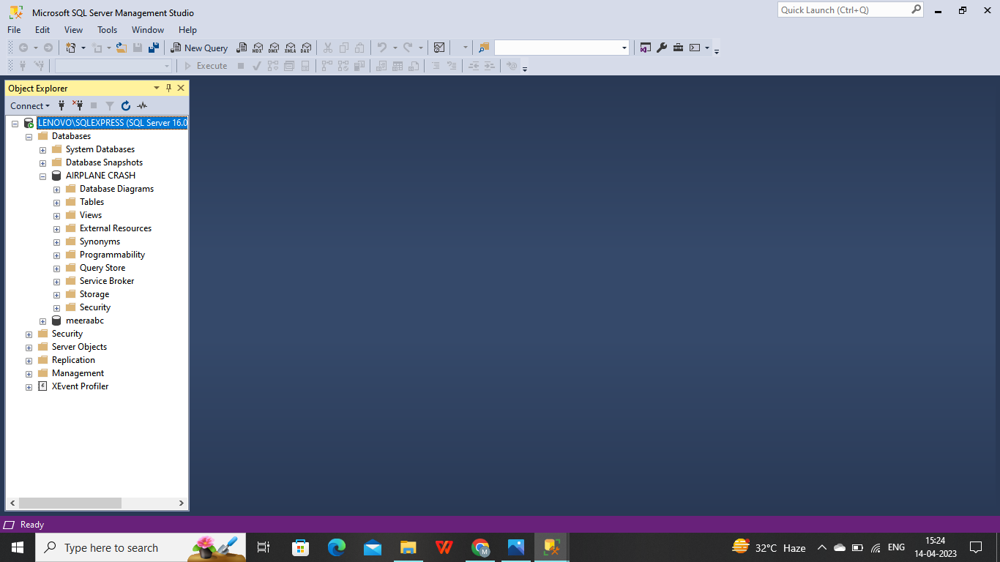

**DATA IMPORT USING MySQL:**

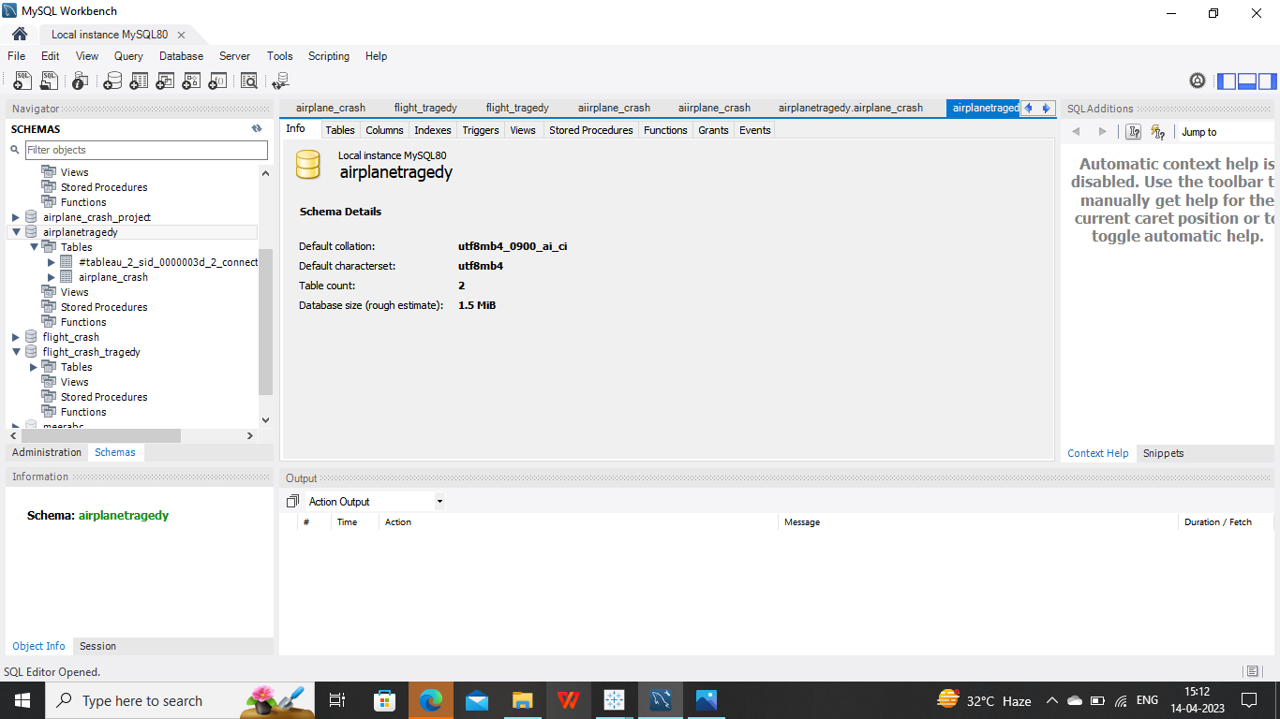

1. **UTILIZATION OF DATA FILTERS:**

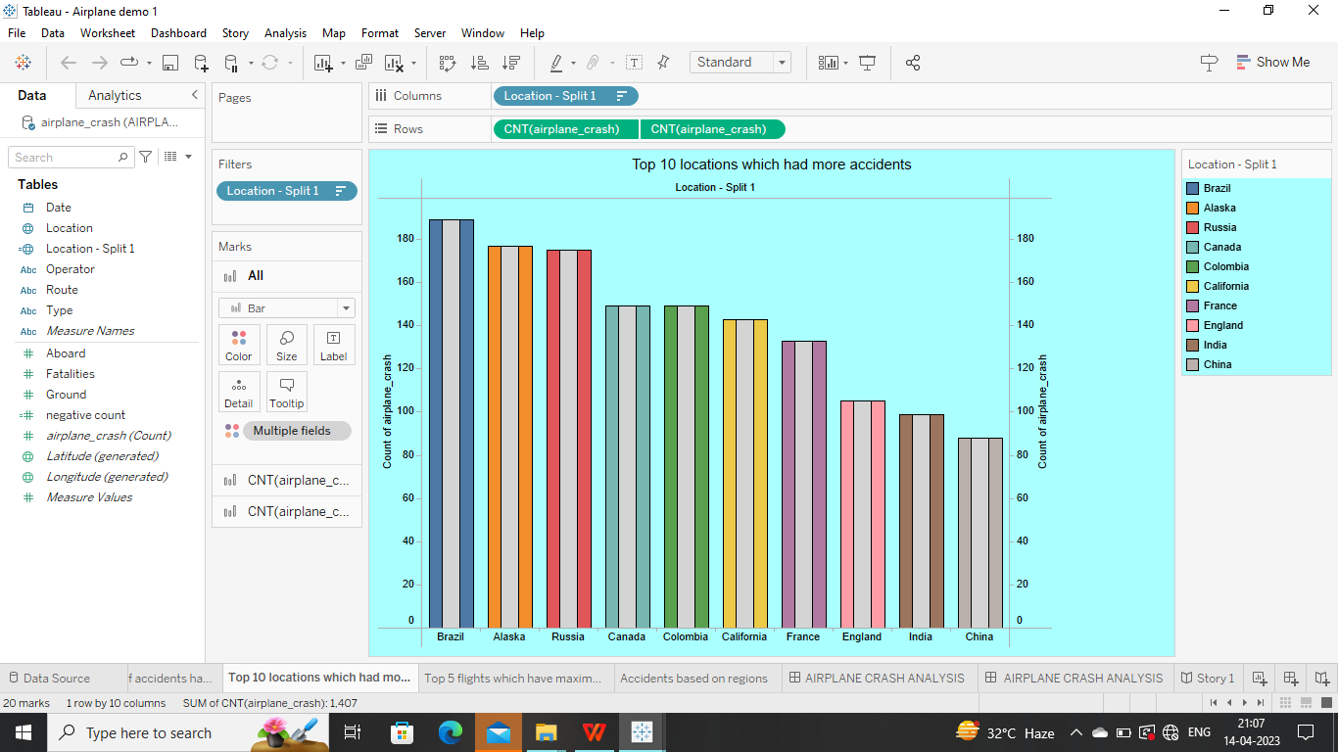

1. **NO.OF CALCULATED FIELDS:**



**4.ADVANTAGES AND DISADVANTAGES:**

|  |  |
| --- | --- |
| **ADVANTAGE** | **DISADVANTAGE** |
| **Helps to determine the cause of error** | **Getting some error in survey** |
| **Identifying the contributing factors involved in crash** | **Legal problems** |
| **Helps to prevent the similar type of accidents** | **Getting some false information** |
| **Avoid the technical error** | **Difficult to get the information from grounded people** |
| **Helps to Improving the technical error** | **Hard to get the information about airplane crash.** |

**5.APPLICATIONS :**

**It is applied in the many area like**

**Medicine**

**Crime**

**Education**

**Enivironment**

**Aviation accident analysis**

**For the purpose that,**

**Improving the safety**

**Identifying if it is really unexpected or planned**

**For doing Analysis**

**Identifying cause of error, technical issues, survival rate etc.**

**Prevent similar type accidents.**

**6.CONCLUSION:**

**We done our project by using tableau. In our project we build the visualizations, and we drag all the visualizations to our dashboard and same as we drag the visualizations to our stories also. After that we publish the visualizations, Dashboard, Story in Tableau Public. Then for the next level we done the web integration by using Bootstrap made.**

**In our project we understood how to analyze the data and how to create the new charts, filters etc.**

**7.FUTURE SCOPE:**

**These are the future scopes to build the project next level,**

**The project is able to predict whether the airplane will be safe or not. The period after which an airplane has to go under the maintenance stage can also be included with the project. Hence the project will be one stop destination to check the airplane crashes and the cause of error and the period after which the flight undergo the maintenance.**

**THANK YOU**